**Deploying an application using Kubernetes Manually**

LINT ERROR

HTML with incorrect HTML END TAG on last line causing error.

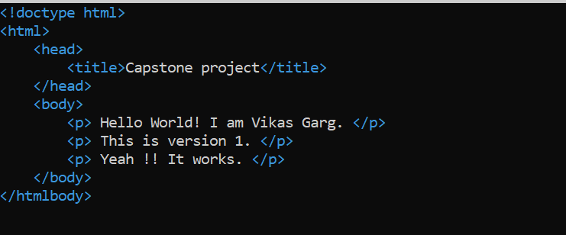

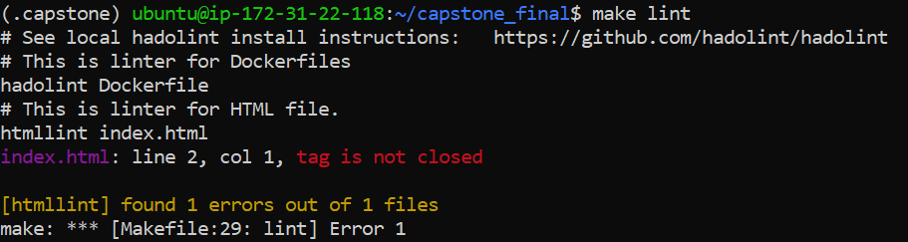

**HTML LINT ERROR FIXED:**

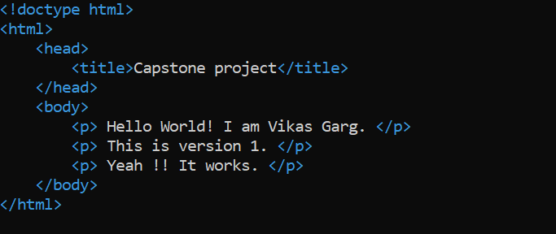

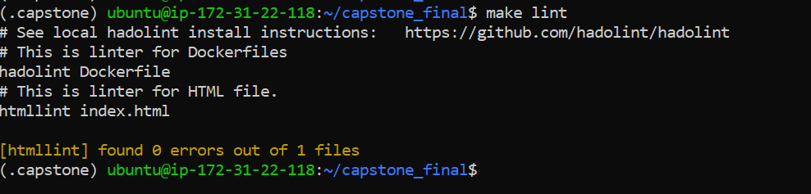

**Image build and docker container started to run on the Port 80.** 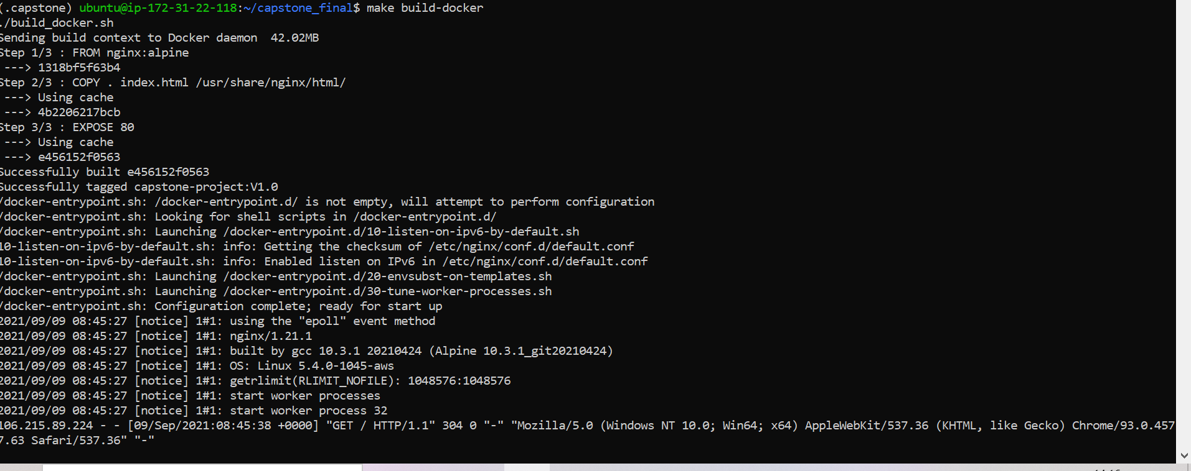

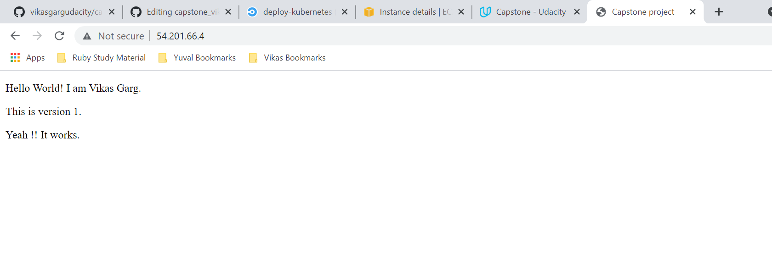

**Image uploaded to DOCKER HUB**

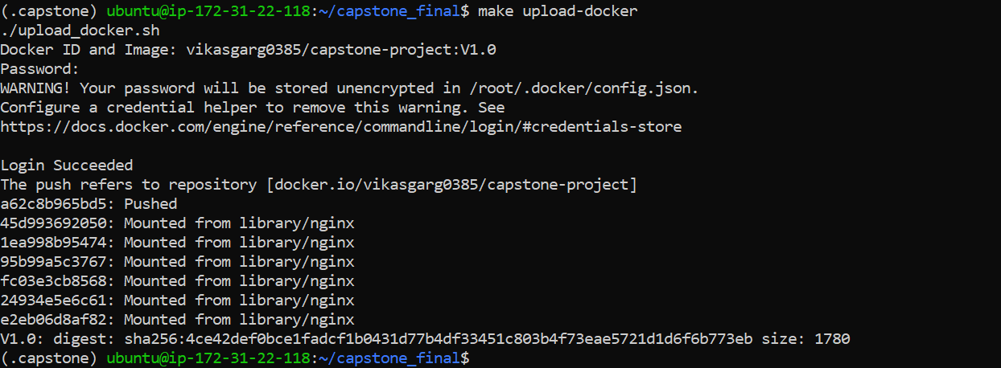

**Creating EKS Clusters, Control Plane and Nodes)**

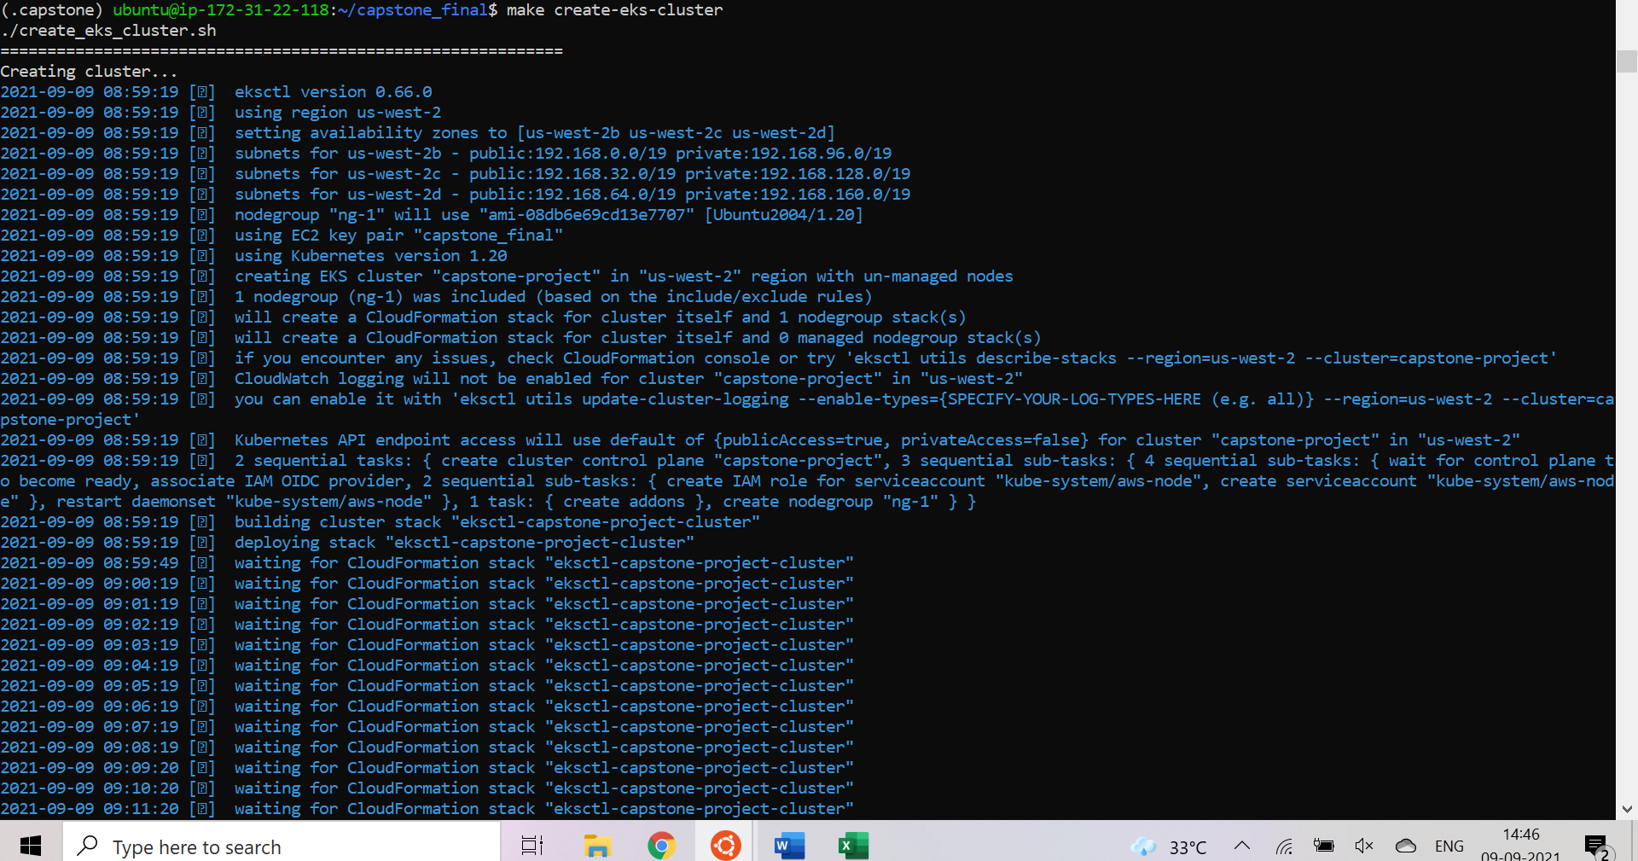

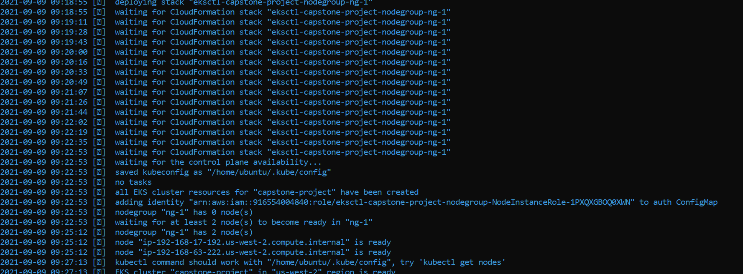

**Create Deployments and Services:**

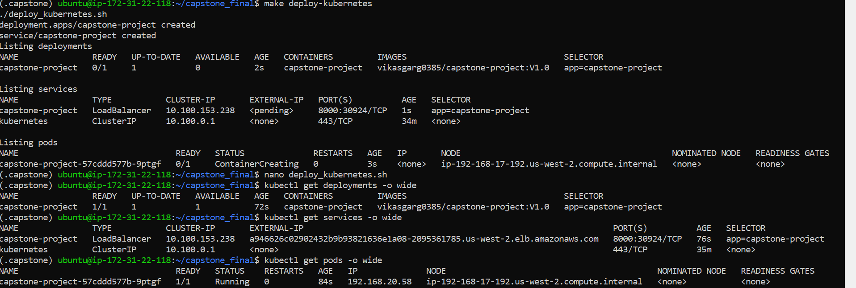

**Load Balancer:**

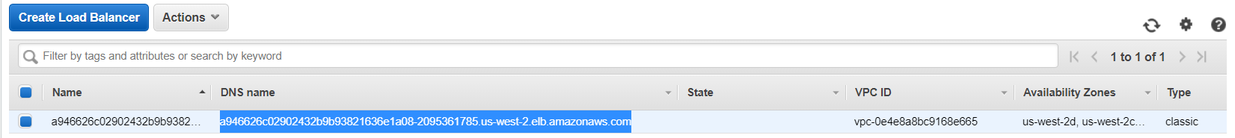

**Website Output:**

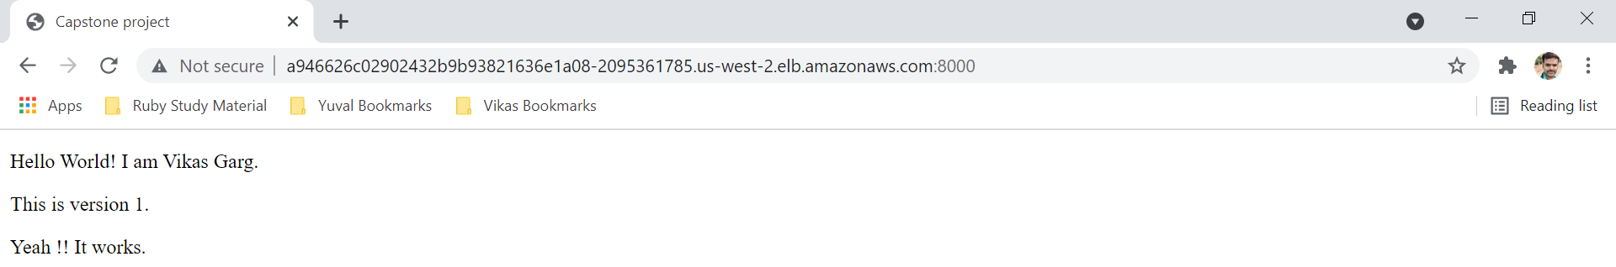

**Updates done to INDEX.HTML**

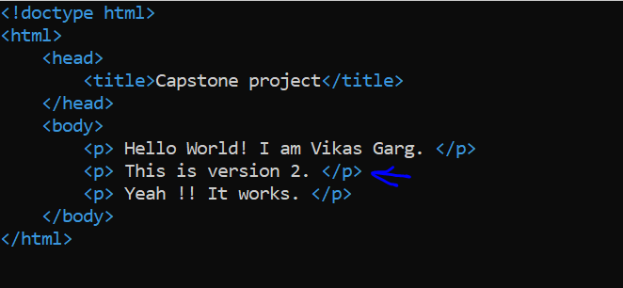

**LINT the file, build the docker Image and upload to DOCKER HUB. Remember to change the Version as “V2.0”**

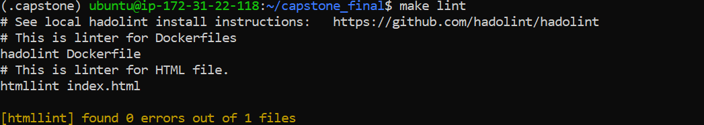

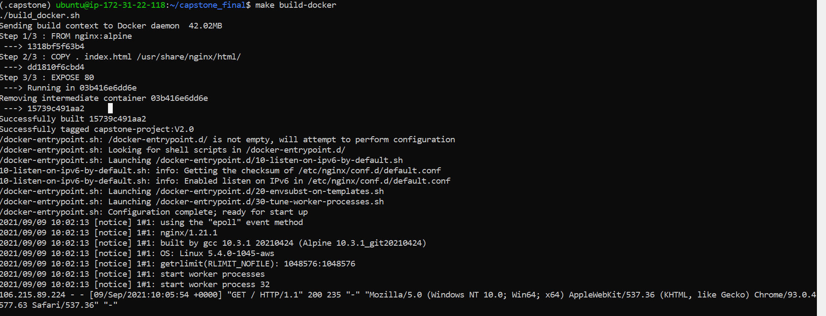

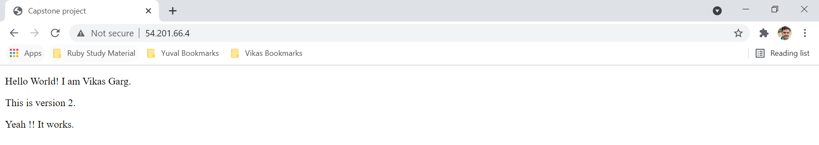

**Perform Rolling Updates:**

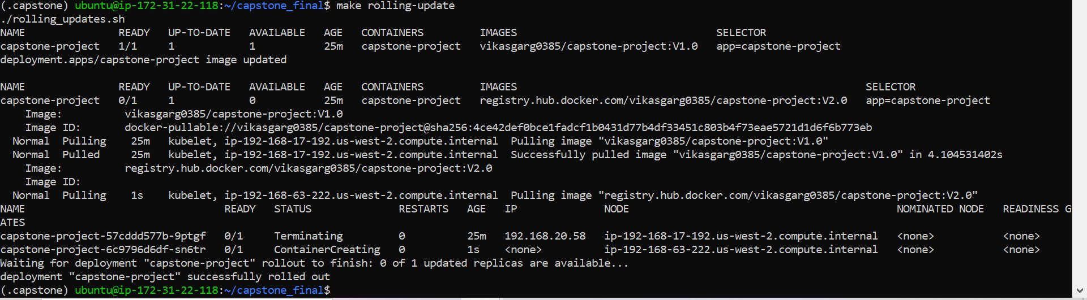

**Check the Load Balance DSN:**

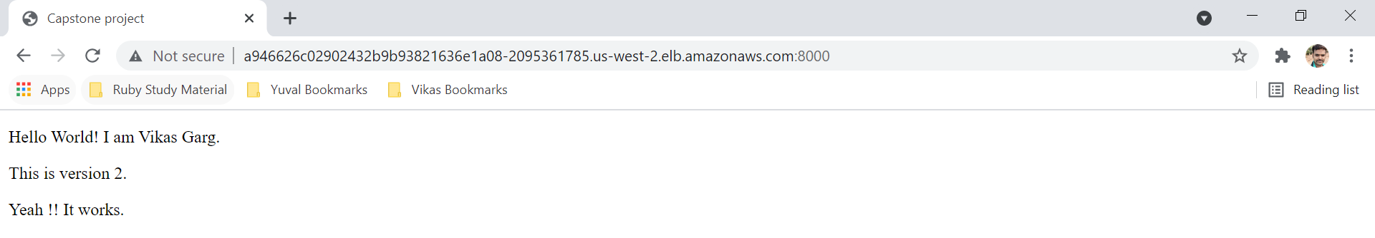

**Rollback Deployment:**

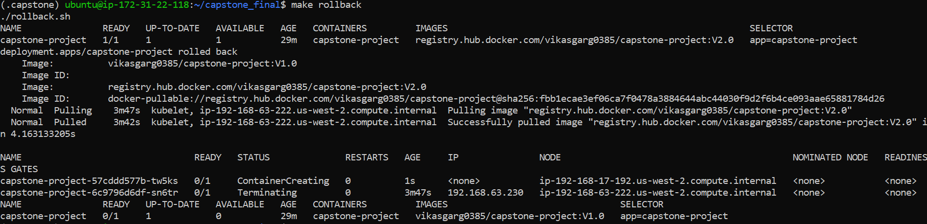

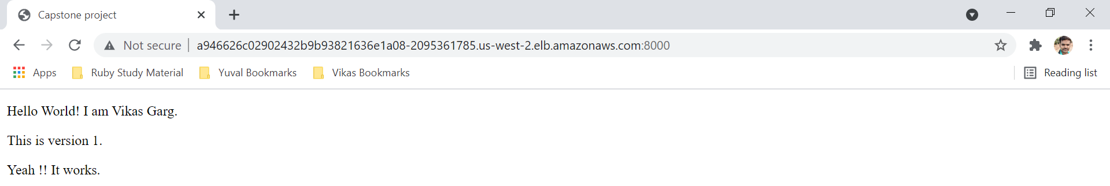

**Cleanup Resources.**

